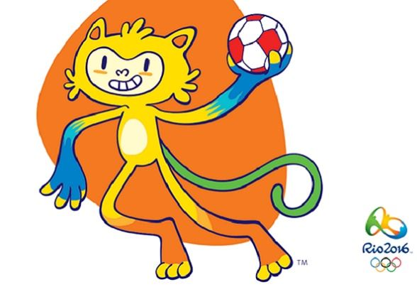
Children’s Olympics

Come and join us at Belmont Community Centre on
Saturday 20 August 2016 from 10 am to 12.30 pm

Open to all children between the ages of 5 to 10 years
The cost is £3 per head and will include food and games.
Booking is essential so please reserve your places on 01432 263415

