Provision of Emergency Living Pods as part of Winter Provision of Accommodation to Rough Sleepers.

As part of Herefordshire Councils response and provision of emergency winter accommodation for rough sleepers in the county, the council will be purchasing emergency accommodation pods to augment the provision of a dormitory shelter at Symonds Street Hereford. Initial plans had been to site four pods, in pairs, on land owned by Voluntary Sector partners. Due to leasehold agreements this is not now possible.
Initial discussion with Mr James Hughes (Herefordshire Council Parking Service’s Manager) have taken place to seek his support to place four of these pods, in pairs, on Council owned car park spaces. Mr Hughes has provided his support to place these pods in the following locations, subject to Herefordshire Council’s Property Services permission being granted.
This paper is to seek that approval and support for the submission of planning applications to secure temporary planning permission in order for Herefordshire Council to deliver this statutory provision of accommodation at the two locations set out below.
The locations are: -
- Venn’s Close Car Park.
- Hereford Bus Station Car Park.
The following maps and images depict the exact locations identified by Mr Hughes as the most suitable positions to site the pods.
The pods would occupy an area equivalent to three parking spaces.
The pods obtain power via with a PV Panel that stores energy in a battery to power an internal light and USB port. They have a single bed and a chemical toilet (which will be emptied by contractual arrangement).
It is proposed to use the pods to accommodate people sleeping rough, between early December and late April 2024. At the end of this period a review of arrangements will take place and these pods may be relocated, this will be reviewed according to demand. The option to leave them sited and/or to remove and relocate them back to the same location for the winter of 24/25 and beyond is requested.
A range of support options are in place from the statutory sector through the BRAVE pathway and the Rough Sleeping Outreach Team staff. These are augmented by the Community, Faith and Voluntary Sector to deliver food, provisions, clothing and ability to attend to personal hygiene and clothes washing.
Planning Permission is being sought for the Symonds Street Acorn building to change its use temporarily and to site four pods within the curtilage of the buildings boundary. This is being progressed jointly by colleagues from the PMO and Property Services already.
Herefordshire Councils plans for the provision of Winter Emergency Accommodation have the support of Councillor’s Gandy, Gennard and Milne, Hilary Hall and D.L.T.
Appendix 1 – Pod schematics.
Venn’s Close Car Park
Map 1 – area with spaces marked
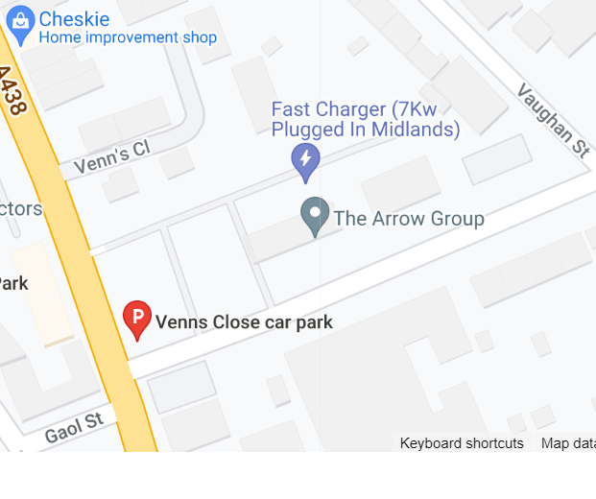
Proposed site of pods
Dormitory shelter
Acorn Building

Image 2 – depicting space for pods
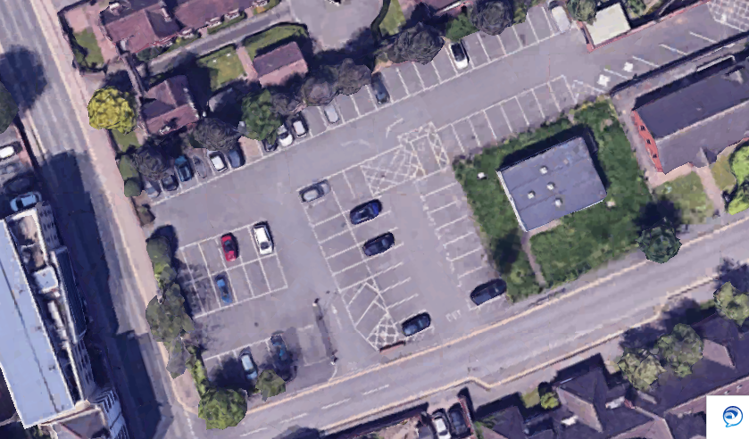
Proposed site of pods

Hereford Bus Station Car Park
Map 2 – area with spaces marked
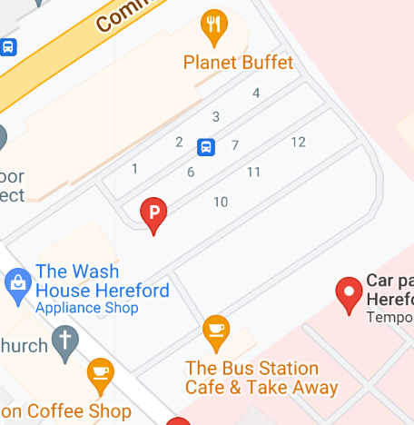
Proposed site of pods
Image 2 – depicting space for pods
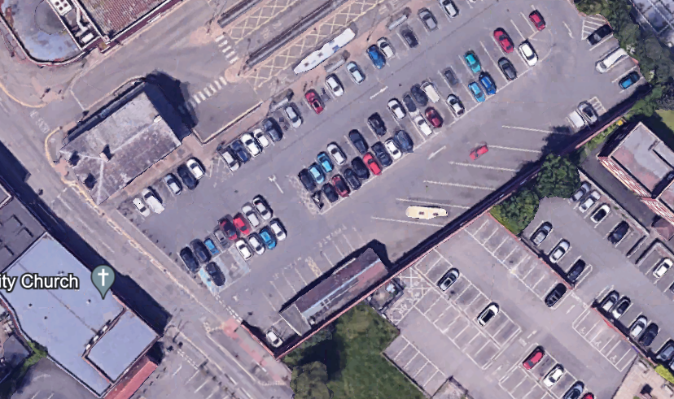
Proposed site of pods

