Objections to the development of the Three Elms Site
Land at Three Elms, North East Quarter To the north east of Huntington and bounded by Three Elms Road and Roman Road Hereford Herefordshire HR4 7RA

- This proposed development site is on a flood plain Figure 1. This is not an optimum development site and would be better utilised as a flood water retention zone for the downstream urban conurbation. The site has a natural tendency to flood during peak storms and could retain much more water if developed as a City Flood Retention Area as part of the Climate Emergency Measures. A new reservoir would also be much more beneficial for biodiversity off-setting impact elsewhere.

- The surface water run-off from this development will compound the existing flood levels in the downstream urban conurbation, Figure 2. Yazor Widemarsh and Eign Brooks will flood the City. This excess run-off could result in considerable increased liabilities for City residents and businesses.

- The proposed development site surrounds a Conservation Area, best conserved for the residents of the City as a Historical Hamlet in an area of natural beauty. This brook and surrounds are noted for the rich array of wildlife using the brook as a corridor to migrate through from the country into the City and back. This is currently refuge and habitat for many fish, birds, bats insects and mammals including badgers and otters.

- The proposed development is over a vulnerable commercial aquifer (Figure 3) with a complex, near surface, geological boundary of intermixed clay and gravels. Site not suitable for development. Reports on the complex geology by WYG expose the risks of breaking into perched water tables or releasing near surface secondary aquifers into the site and downstream into the City. The term superficial aquifer means it is hosted by superficial deposits. It is far from superficial in its importance to the region.

- Hereford City has two major industries, employers and taxpayers who depend on the commercial aquifer that underlies this proposed site. Excavations for footings and drainage of houses, roads and ponds could contaminate commercial groundwater. The main commercial aquifer is below and upstream of proposed developments and layouts have already changed to reflect the complexity and risk of contaminating the ground waters. Why risk such a great loss to the City and County for just 350 houses?

- The aquifer boundary Source Protection Zone 2 is poorly defined (Figure 4) given investigation by WYG and Groundsure shows greater than 10m of groundwater below the proposed site and recharge from the west and north. The proposed development site straddles the boundary, but the boundary does not cover the full extend of the water source. Detailed investigation showed extensive groundwater extends north under the site. In the light of evidence presented by WYG the Environment Agency should revisit the poorly defined SP2 zone and extend it further North.

- Future liabilities for the proposed development will be passed on to the householders via a company to administer the site specific but who will be responsible for future issues arising from floods and contamination downstream? We will all pay more council tax.

In this objection I will refer to the following two reports:
Three Elms Development, Hereford Hydrogeological Risk Assessment Desk Study & Site Investigation Report A101670 by WYG. Referred to as the WYG desk study.

The Groundsure Enviro Insight Report Appendix 11.4 Referred to as the Groundsure Report
Building on a flood plain during a climate emergency
It is inappropriate to build on an important Flood Plain during a Climate Emergency, upstream of the biggest City in the County. Unfortunately, this flood zone map below does not show the contours of two stream locations running through the proposed development and they are not show on any planning proposals either. Why not?
The developers still do not understand the complex relationship between the groundwaters and the surface drainage. Recent observations show a new high flow stream running north south through the middle of proposed developments. Leaving all this detailed investigation and mitigation to reserved matters is asking for trouble. The site is unsuitable, and a full investigation would show this.
Figure 1 Map showing Flood Zones along the Yazor Brook and the proposed development site.
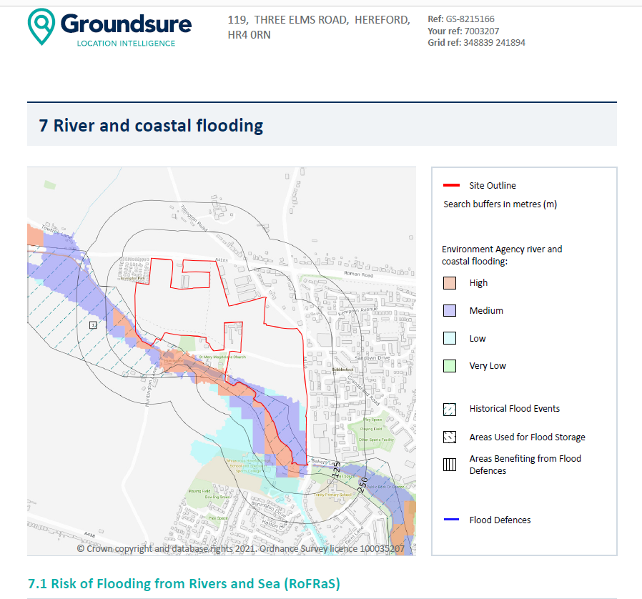
Source: Groundsure Report (page 83 of pdf)
Soil sealing of the proposed site would result in increased short term run-off during storms with an increasing likely hood of more extensive flood damage to City residential and commercial buildings. This 350-house proposal is the initial stage of the much more extensive 1,200 house development proposed previously. Consider the cumulative effects as this is the first stage of a major development. If taken of its own, this 350-house development is surely not worth the risk of contaminating the aquifer and destroying the unique natural setting of the conservation area.
Map showing the vulnerability of the City of Hereford to flooding from increased volumes of surface waters flowing from the proposed development at Three Elms to the west. Note the wide zone to the west were the flooding from Three Elms joins the network of City Brooks. Consider the margin of error for a higher flood event influenced by a larger volume of water resulting from surface run-off in terms of damage to commercial and residential properties.
Figure 2 Hereford City Surface Flood zones from City Brooks
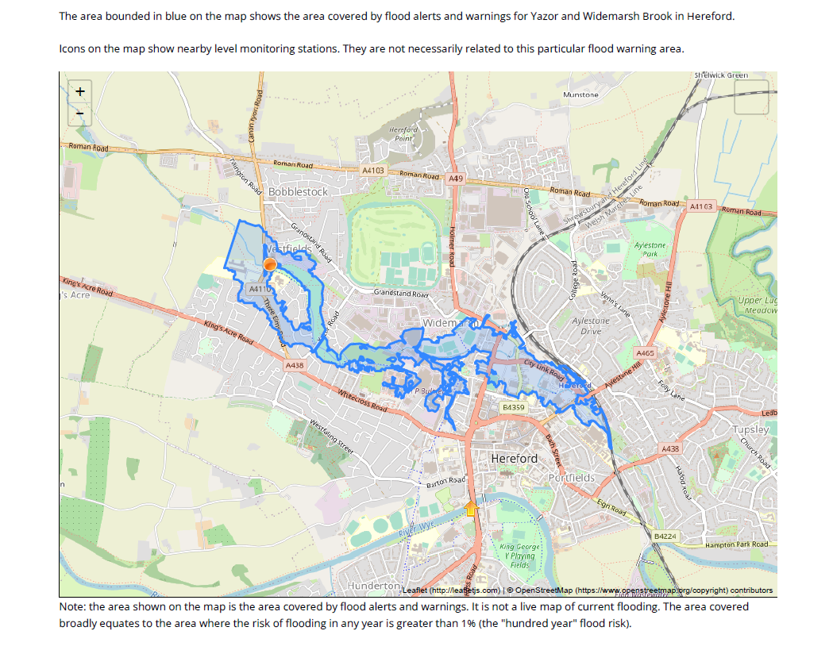
Source: https://riverlevels.uk/flood-warning-yazor-and-widemarsh-brook-in-hereford#.Yv5XsnbMI2w
The complex geology should be examined through detailed investigations before outline planning is granted. This should be a red flag to development from the technical perspective because discovery will no-doubt result in more complex relations between the surface water and the aquifer, determined by the rise and fall of the ground water levels in tongues of gravel through the clays.
This proposed development site is located on a complex geological boundary between clays and gravels, often so complex that the exact location of interlocking gravel layers within clays have not been mapped or identified between the limited sample sites. The contractor, WYG, uses available data from samples and boreholes to project a model of the clay and gravel boundary. This is a critical junction because the aquifer is within a few metres of the surface and rises to surface during flood events. If the simplistic geological model presented is wrong the aquifer will be breached.
The WYG desk study was presented as evidence of a hydrological risk assessment for the proposed development, but it has many significant unknown parameters in the modelling which I will highlight as serious risks to the aquifer quality and the downstream urban conurbation from surface waters as a direct result of this proposed development. The information presented in this report is based on the strata observed in the exploratory holes, the results of the site and laboratory tests, and information obtained as part of the desk study.
WYG take no responsibility for conditions that have not been revealed by the exploratory holes, or which occur between them. Whilst every effort has been made to interpret the conditions between investigation locations, such information is only indicative, and liability cannot be accepted for its accuracy.
While this get-out clause is reasonable for most reporting of geological and hydrological reports it is an unacceptable risk for such a complex proposed development site, in a known flood zone over a commercial aquifer and upstream of a major conurbation.
The proposed layout was changed, in relation to the recently identified complex boundary between the clays and the gravels. The developer is proposing excavated retention ponds for flood waters over the areas previously outlined for housing.
WYG, the consultants, illustrated the limited thickness of the clay cap over the aquifer in some of their cross sections of the boreholes drilled. On these sections the level of ground waters is indicated showing very near surface levels. Building more ponds over the thin clay zone must entail excavations in the most vulnerable areas. This is a high-risk proposition with a potential major impact on commercial and social levels of the County if the aquifer is breached.
This application should be refused on the grounds that it is far too high technical risks for a minor housing scheme. If it was for one or two thousand houses, then pushing the envelope may be justified. Why risk everything commercial in the City for such a minor development without far more technical understanding of the groundwater depths, containment and vulnerability?
Figure 3 Vulnerable groundwaters map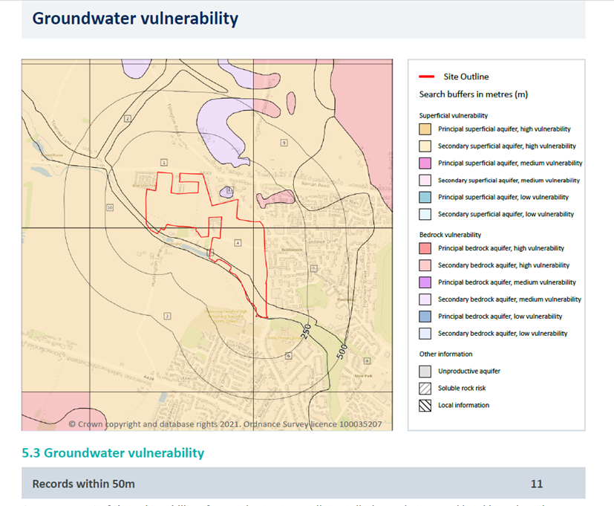
See pages 43-45 of the Groundsure Report on Three Elms (Appendix11.4 in the planning documents) on vulnerability of the aquifers. Note site map with locations 3, 4 and 5 have the thickness of vulnerable aquifer > 10m in the proposed development zone. Note also that the site of location 4 is in the centre of the proposed development but outside the Source Protection Zone 2. This raises the question about the accurate definition of the boundary to Source Protection Zone 2.
Site 4 on the map is noted as a highly vulnerable superficial aquifer. That means it is hosted by superficial deposits ie the gravels of an ancient river bed, not that it’s of superficial importance. Quite the contrary, it is our City’s most important underground aquifer marked as highly vulnerable. It is a red flag for developers and should be a red flag for the planning committee if they were given a full technical explanation.
The inaccurate modelling of the complex geology within the proposed development is combined with the changing models for ground water flows prepared and presented to WYG by the Environment Agency.
We know that this Government’s Environment Agency (EA) has suffered substantial budget cuts and failed to protect the Nation’s water courses over the last decade. The resultant changes in teams, loss of staff and poor quality of data recording is well documented in the press. With this in mind, we must be extra cautious reviewing the current EA modelling and monitoring of the City groundwater aquifer. How accurate is the SPZ2 boundary and what are the consequences if it is wrong?
Despite all the groundwater modelling here and permitting abstraction we still suffer complete loss of flow in our natural Hereford City Brooks. The Environment Agency’s estimated mass balance figures for the aquifer at Three Elms have changed substantially during the last decade with data capture and more detailed modelling, but the links between aquifer and surface waters are still poorly understood.
For example, water abstraction licenses are granted only if no downstream detrimental damage is foreseen by the Environment Agency, but the City Brooks have dried out several times in the last five years during low rainfall while abstraction at the rate of 3,000 to 5,000 m3 a day per borehole is permitted from numerous boreholes by the main industrial sites detailed in the Groundsure Report (pages 47-76). Is this loss of biodiversity calculated collateral damage or the inaccurate assumptions made by previous modellers of the aquifer?
The Environment Agency does not have the full picture on the relationship between the Ground waters at Three Elms and the abstraction impact on the downstream environment. If it did then surely, we would not have to rescue the fish and experience the loss of invertebrate life almost annually on water courses that used to run all year round.
According to the WYG report, guidance released by the EA (Environment Agency, 2008) states that activities that have the potential to affect the quality or quantity of groundwater must not result in groundwater pollution.
This proposed site has clays layers over gravels hosting the commercial aquifer and the water table is a short distance below ground. This categorisation illustrates the aquifer is most vulnerable where the clays are interspersed with gravels.
Groundwater is less vulnerable where thick clay overlies deep groundwater. The risk of groundwater pollution from a housing development depends on the depth and nature of excavations in clays and gravels. If the gravels are disturbed the ground water flows will be compromised and aquifer purity diminished. In addition to the commercial risks this development could also threaten the biodiversity of Hereford City brooks. The run-off from housing estates includes surface waters often contaminated by householders’ external washing machines and car washing activities.

Building should not be permitted on this poorly defined Source Protection Zone 2
In my opinion no planning should be granted for development adjacent or overlying this outlined Source Protection Zone 2, as shown in blue in the map by Groundsure below because the boundary is in the wrong place. This boundary position is out of date because we know the body of ground water stretches further North than SPZ2, under the proposed site. In fact, according to the borehole investigation, the groundwater rises closest to surface through the area just North of the Yazor Brook within the proposed development area. This is a clear indication that the position of the SPZ2 boundary should be moved to account for the additional detailed sampling identified in surface examination.
The proposed development site encroaches the Northeast boundary and indeed overlies groundwaters, more than 10m thick, according to ‘Site 4 notes on the Groundwater Vulnerability Map’ in the Groundsure Report page 43.
Figure 4 The Abstraction and Source Protection Zones
