Objections to the development of the Three Elms Site continued from 18/8/22 submission
Land at Three Elms, North East Quarter To the north east of Huntington and bounded by Three Elms Road and Roman Road Hereford Herefordshire HR4 7RA

‘The probability of a risk occurring has been reviewed by a hydrogeologist and adjustments made based on professional judgement, to take account of specific local circumstances relevant to the site.’ Tetra Tech Hydrological Risk Assessment Report
This is the key statement from the hydrological risk assessment conclusions. It states adjustments were made based on professional judgement to take account of specific local circumstances relevant to the site. This raises several RED FLAGS
- The Tetra Tech risk assessment report is based on the author's conceptualisation of the current ground conditions and assumption that they will largely remain the same between the time of this assessment and the commencement of development, but ground conditions have already changed. Tetra Tech and the Environment Agency did not locate the underground water course that now runs permanently above ground as a stream South through the middle of the proposed development site, west of the Beeches Business Park under the Roman Road along the small valley and down to the highly sensitive area around the Yazor Brook. The intention to cover low lying areas with clays removed from higher areas risks breaking secondary perched water tables, generating saturated unstable ground and pollution of the vulnerable commercial aquifer.
- Why roll the dice with reserved matters for outline planning permission when a geophysical survey could clearly assess the risk of failure more accurately by measuring the depth of clay cover over the Yazor gravels and vulnerable aquifer gravels. The presented maps of clay thickness for staged site construction are based on sparse sampling and exhibit a typical naive ‘fried egg pattern’ expected from a poor data set. A geophysical survey could identify precisely how thick the cover is in between the sparse sample points. The clay layer over the gravel above the aquifer is, in part, less than 0.5m thick according to Environment Agency observations in its response. Given the strongly worded disclaimer in the WYG desk study, used to inform the Tetra Tech risk analysis, the Council is exposed to significant risk due to the unknown geological variables. A detailed survey would enhance the current modelling assumptions and may negate key geological and hydrological assumptions used in the development proposal.
- Why is the local knowledge of the connectivity between brooks and abstraction rates not considered as part of the professional judgement. The observations of groundwater levels from just two boreholes compared with water levels in the Yazor Brook are stated as evidence that the surface flows are not connected to the aquifer. City residents know the Brooks can rise and fall irrespective of rainfall in the catchment, clearly pointing to variable abstraction rates. Licensed boreholes give Heineken and Avara (formerly Sun Valley) rights to pump over 4.38 Olympic swimming pools a day from the gravels (10.98 million litres daily) and the average abstraction is 1.75 Olympic swimming pools a day (4.38 million litres daily).

- Tetra Tech noted that building on a floodplain requires bigger drainage and flood retention tanks to protect the downstream environment. Surely this statement is enough to rule out any long-term major housing developments across the floodplain so why start developing it? It is proposed to provide increased flood storage by undertaking excavation. The excavation constraints limit the storage volume that can be provided within above ground SuDS. It is expected that additional below ground storage will be required within the areas of public open space to the south of the Site to provide the storage volume required. It frequently floods immediately south of the site and the City can’t afford to keep its existing underground sumps and drainage systems clear of blockages.

- The risk to this County of failure in developments over a vulnerable commercial aquifer have not been spelt out to the public. Breach of the surface gravels and pollution of the aquifer could result in loss in jobs and quality of life for generations in Hereford City. Why has the professional judgement based on local knowledge not laid out the full risks of proposed excavations in plain English. Is it inherent bias in this technical reporting that errs towards development when professional judgement sweeps the detailed risk of failure into the small print of an appendix? The presentation for public relations is a glossy brochure but the inherent risk to the City and County is buried in the appendices.

- The Environment Agency stated, in December 2021, it was adjusting the boundaries of the Source Protection Zones around onsite boreholes. The current SPZ merged data set on the National system has not changed. The boundary of aquifer source protection zones relates to proximity of boreholes and the time it takes for water to travel in the aquifer to the borehole. The on-site boreholes, shown as A and B in Groundsure report sect 5.6, could be re-designated SPZ1 and prohibit any development in the South-eastern portion within 100m radius. SPZ2 is technically defined as 400 days of flow away from or 250-500m away from the nearest abstraction points. The new SPZ2 boundary for the active on-site boreholes should extend further north and east by 250m-500m reducing the proposed development area. The new Source Protection Zones 1 and 2 boundaries should envelop a wider area of the proposed development site given the strict technical definitions. This does not appear to be taken into the design of the latest development plans which closely follow the original SPZ2 boundary. THIS IS A BIG RED FLAG

Impact on development of the redefined Source Protection Zones
  - A 250m radius around Borehole A takes out all proposed housing south of the Huntington Lane roughly 20-25% of development and
  - a 500m radius takes out all proposed housing north of the Huntington Lane and between Beeches Business Park and the Farm, say 40-50% of development

- How can we as the public be expected to make informed comment before the Environment Agency has published its new source protection zones which should negate 25% to 50% of the proposed development site?
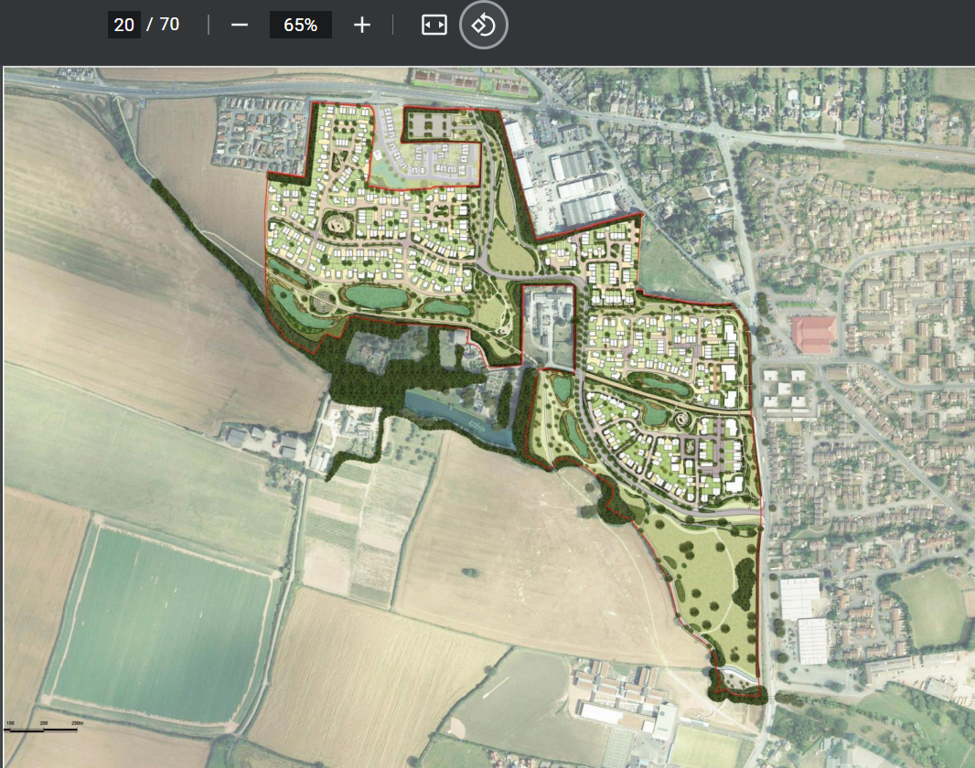
The current published SPZ boundaries for Hereford are on the National system. They do not yet reflect and enlarged protection area around the on-site abstraction boreholes, close to the intersection of Bakers Lane and Three Elms Road.
https://environment.data.gov.uk/arcgis/rest/services/EA/SourceProtectionZonesMerged/FeatureServer

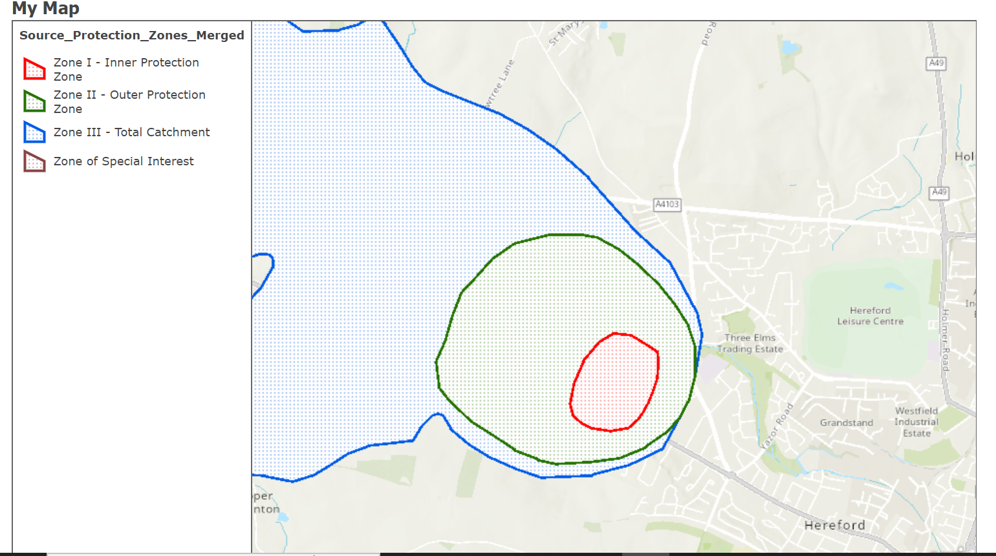

Background notes and comments
DEFRA/Environment Agency response with reference to SPZ designation dated December 2021

