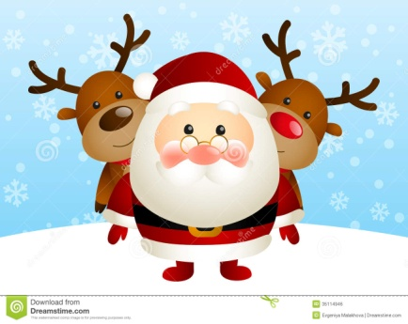
CHILDREN’S
CHRISTMAS PARTY
Belmont Community Centre
Saturday 17th December
2 – 4 pm
£3 a ticket
Booking is essential – drop in or book via 01432 263415
Limited Spaces available!

Food and drink included!
Games and also an extra special visitor!

