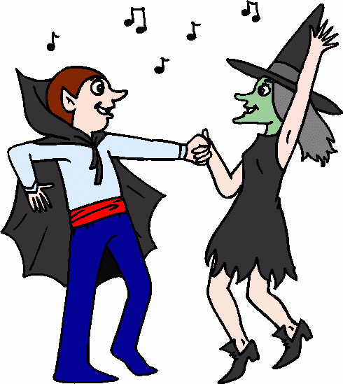
Adults Only Halloween Fancy Dress Party

Come and join us at Belmont Community Centre on
Saturday 29 October 2016 from 6 pm.

Cost is £5 per head including food and games. Please bring your own “bottles”.

Booking is essential so please reserve your places on 01432 263415.
