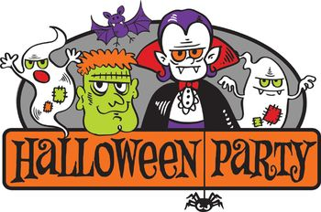 Children’s Halloween Fancy Dress Party

Come and join us at Belmont Community Centre on
Saturday 29 October 2016 from 2 pm to 4 pm.
Cost is £3 per head including food/drink and games.
Booking is essential so please reserve your places on
01432 263415.



