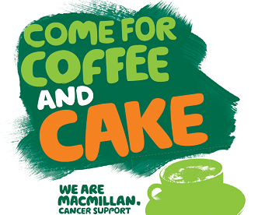

Come and join us at
Belmont Community Centre on
Saturday 1 October 2016 from
10 am to 12 pm



