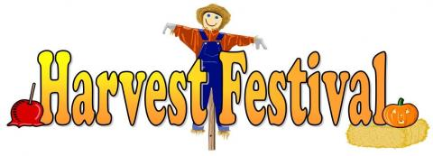
Come and join us at Belmont Community Centre on
Saturday 17 September 2016 from 2 pm to 4 pm

Songs, nibbles and good company

In the spirit of Community we are not charging for this event but would ask people to “donate” items that we can then distribute to the needy in our area.

Booking is essential so please reserve your places on 01432 263415. Transport available if required.



